TITLE OF THESES / DISSERTATIONS
عنوان رسالة الماجستير/الدكتوراه باللغة العربية

A thesis/dissertation submitted in partial fulfillment of the requirements for the Master Degree/ Doctor of Philosophy in Pharmacology, Department of Pharmacology and Toxicology, College of Pharmacy, King Saud University

BY
STUDENT NAME
445123456

Supervised by
Dr. Mohammed Abdullah

2024 G /1446 H
TITLE OF THESES /DISSERTATIONS
STUDENT NAME
This dissertation is approved as a creditable and independent investigation by a candidate for the Doctor of Philosophy in pharmacology degree and is acceptable for meeting the dissertation requirements for this degree.

_________________________________________
Advisor Name, Ph.D.
Thesis Advisor Date

_________________________________________
Committee Member Name, Ph.D.
Thesis Advisor Date

_________________________________________
Committee Member Name, Ph.D.
Thesis Advisor Date

_________________________________________
Committee Member Name, Ph.D.
Thesis Advisor Date

_________________________________________
Committee Member Name, Ph.D.
Committee Member Name Date

This dissertation is dedicated to
ACKNOWLEDGEMENTS
Write your acknowledgment here in full sentences.

ABSTRACT
TITLE OF THESES / DISSERTATIONS
STUDENT NAME
2024 (G) /1446 (H)
Write your abstract here. (No more than 350 words)

الخلاصة
عنوان رسالة الماجستير/الدكتوراه
اسم الطالب/ه
2024 (G) /1446 (H)
أكتب الخلاصة هنا

CONTENTS
ABBREVIATIONS………………………………………………………………………vi
LIST OF FIGURES……………………………………………………………………...vii
LIST OF TABLES……………………………………………………………………...viii
ABSTRACT………………………………..…………………………………..…………v
INTRODUCTION……….………………………………………………………………..1
MATERIALS AND METHODS…………………………………………………………2
RESULTS…………………………………………………………………………………2
DISCUSSION…………………………………………………………………………….4
CONCLUSION…………………….…………………………………………….……….5
REFERENCES…………………………………………………………………..…….….5
ARABIC ABSTRACT…………………………………………………………..…….….5

ABBREVIATIONS
mm millimeter
sd standard deviation
se standard error
M molar
conc concentration

LIST OF FIGURES
Figure 1. Time course of effect of Compound A…..…………………………..…………4
Figure 2. Time course of effect of Compound B…………………………………………4
Figure 3. Time course of effect of Compound C…………………………………………4
Figure 4. Time course of effect of Compound D…………………………………………4

LIST OF TABLES
Table 1. Effect of Compound A…………………..…………………………..…………5
Table 1. Effect of Compound B…………………..…………………………..…………5
Table 1. Effect of Compound C…………………..…………………………..…………5
Table 1. Effect of Compound D…………………..…………………………..…………5

ABSTRACT
TITLE OF THESES / DISSERTATIONS
STUDENT NAME
2024 (G) /1446 (H)
Write your abstract here. (No more than 350 words)

Introduction
Write your introduction here.

Material and Methods
Write your introduction here

Results
Write your results here.

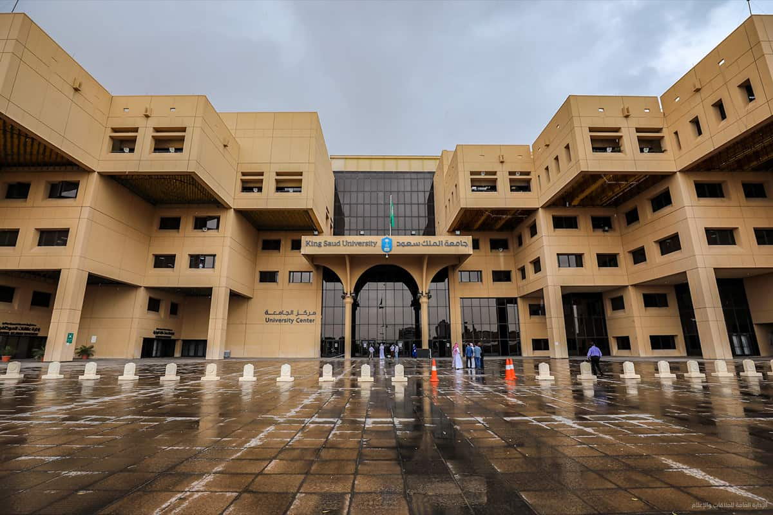
Figure 1. King Saud University Enterance .

"Sed ut perspiciatis unde omnis iste natus error sit voluptatem accusantium doloremque laudantium, totam rem aperiam, eaque ipsa quae ab illo inventore veritatis et quasi architecto beatae vitae dicta sunt explicabo. Nemo enim ipsam voluptatem quia voluptas sit aspernatur au odit aut fugit, sed quia consequuntur magni dolores eos qui ratione voluptatem sequi nesciunt. Neque porro quisquam est, qui dolorem ipsum quia
Table 1. Top 3 TFs regulating the hub genes.
Rank | Transcription Factor | Overlapping Genes
1 | CTCF | SPP1, ICAM1, BCL2, NFE2L2, IL6, TGFB1
2 | TRIM28 | NFE2L2, NOS3
3 | RELA | NFE2L2, ICAM1, GSK3B

Discussion
Write your discussion here

Conclusion
Write your discussion here

References
Reference styles differ significantly across disciplines. However, a common rule is that all references should be single-spaced, with a space separating each reference. No reference should be split across pages. This illustrates 3 most common Reference format.
- Bergen, Phillip J., et al. "Colistin methanesulfonate is an inactive prodrug of colistin against Pseudomonas aeruginosa." Antimicrobial agents and chemotherapy 50.6 (2006): 1953-1958.

- Bergen, P. J., Li, J., Rayner, C. R., & Nation, R. L. (2006). Colistin methanesulfonate is an inactive prodrug of colistin against Pseudomonas aeruginosa. Antimicrobial agents and chemotherapy, 50(6), 1953-1958.

- Bergen, Phillip J., Jian Li, Craig R. Rayner, and Roger L. Nation. "Colistin methanesulfonate is an inactive prodrug of colistin against Pseudomonas aeruginosa." Antimicrobial agents and chemotherapy 50, no. 6 (2006): 1953-1958.

Appendixes (Optional)

